**UML DIAGRAMS**

1. STRUCTURAL DIAGRAMS

A. CLASS DIAGRAM

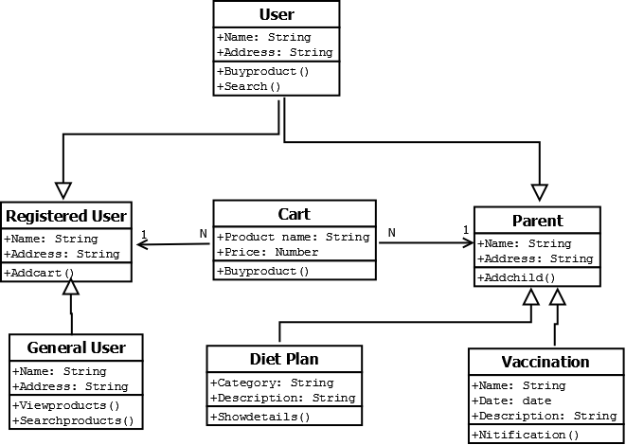

B. OBJECT DIAGRAM

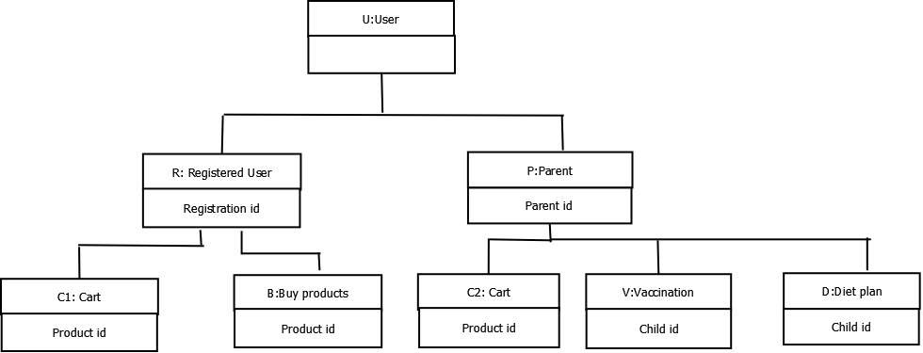

C. DEPLOYMENT DIAGRAM

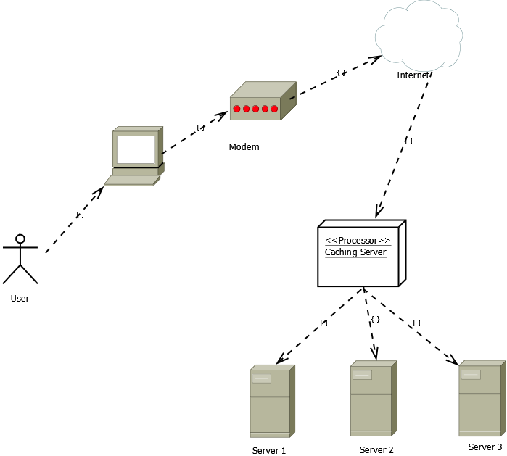

2. BEHAVIORAL DIAGRAMS

A.USECASE DIAGRAM

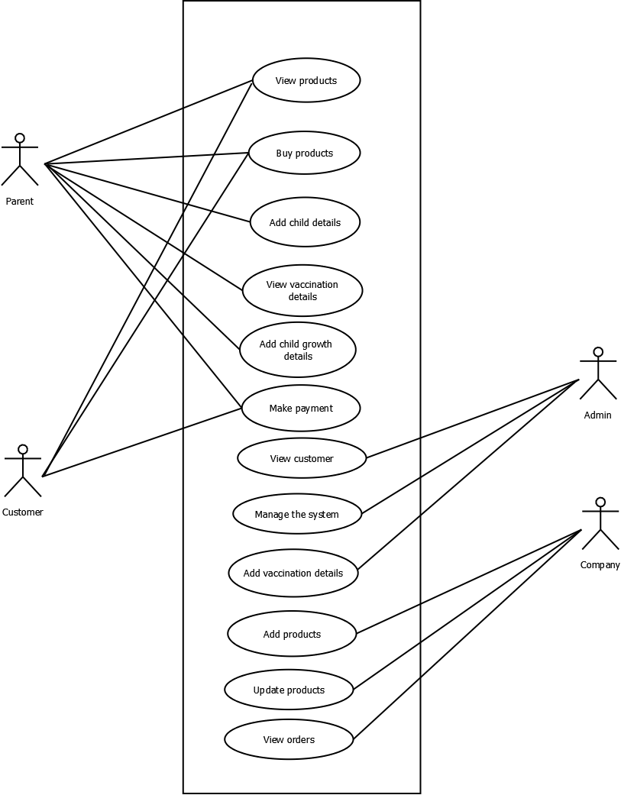 B. SEQUENCE DIAGRAM

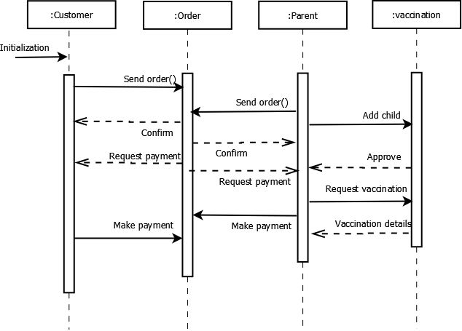

C. COLLABORATION DIAGRAM

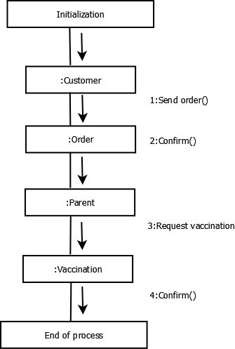

D. STATECHART DIAGRAM

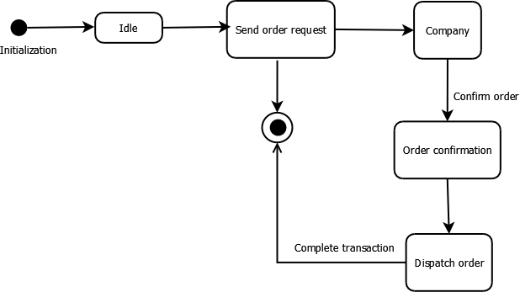

E. ACTIVITY DIAGRAM

